***East West Universty***

***PROJECT***

***On***

University GPA Calculation

Course Title : Object Oriented Programming

Course Code : CSE 107

Section : 02

**Submitted To:**

**Dr. Shaikh Muhammad Allayear**

Department of CSE

**Submitted By:**

**Name: MD. Moniruzzaman khondaker**

**ID: 2012-2-60-056**

**Overview**

* Case study.
* Class diagram.
* Functional flow chart.

### CASE STUDY :

### PROJECT TITEL : University GPA Calculation :

### PROJECT GOAL : A software that will manage all the basic information of the students and other activities such as :

1.Individual profile

2.Total credit he taken & Count the gpa

3.Total student result

4.Search option

**Users:**

**1 .**admin

**2**.student

**2**.teachers

**DESCRIPTION OF FUNCTION** :

1. .Individual profile : Here ,every student will have individual profile like a :

1. NAME

2. ROLL

3. DEPARTMENT

4. BATCH

5. total SUBJECT IN HIS/ HER EXAM HE/SHE ATTEND

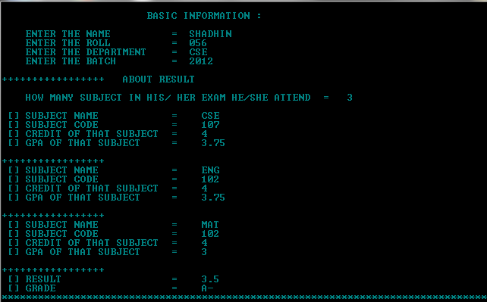

**2**. **Total credit he taken** & count the cgpa

it will calculate , how many subject you have taken and show your cgpa.

**3**. **Total student result :**

You can find out the total student’s result

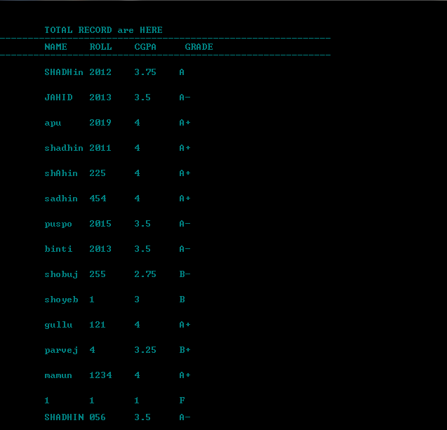

**4**.SEARCH :

You can get a student information & result ..

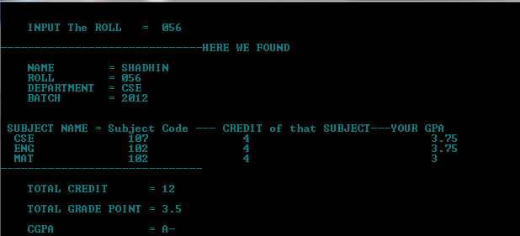

### 

### CLASS DIAGRAM :

TITEL : University GPA Calculation

### CLASS NAME : STUDENT

* MEMBER VARIABLE:

**public:**

* char name[40];
* char roll[10];
* char dep[5];
* char batch[5];
* char subname[10][20];
* char subname[10][20];
* char subcode[10][20];
* float gpa[10];
* float credit[10];
* float totalcredit;
* float subg[10];
* float total;
* int i;
* float grade;
* char gradeno[4];

MEMBER FUNCTION:

**public:**

1. **VOID get()**

It will take your BASIC INFORMATION & GPA (you have got).

1. **Void getgpa();**

It will calculate your GPA … and show you what is your result.

1. **Void file();**

It will store your total basic information in a file ( Individually ).

1. Void gra(float) :

It will calculate the grade .

Header Files:

#include<fstream> //using file

#include<string.h> //character of array

#include<iostream> //C++

#include<stdio.h> //c header file

#include<stdlib.h> //color header file

**PROJECT FLOW CHART**

Start –int main()

Take input ( P )

1 to make a student file

2 to make a search

3 to show

4 to make logout

If p==4

no

yes

Return 0;

Program closed

THANK YOU FOR USING THIS PROGRAM !!!!!!!!

Take input ( P )

1 to make a student file

2 to make a search

3 to show

4 to make logout

If p==3

no

yes

Call ifstream x("RESULT") by object x .It open txt file and show the total history

Take input ( P )

1 to make a student file

2 to make a search

3 to show

4 to make logout

Goto next SLID

It will ask you to input a roll number and the program

Will Call ifstream x(roll) by object x .

It open txt file and show the total history of that student…

yes

no

If p==2

Take input ( P )

1 to make a student file

2 to make a search

3 to show

4 to make logout

no

If p==1

yes

1st it will Call file() function by object x.

In file() function it will take all the basic information of a student and store it in a file .

Individually it will store all the student’s academic record.

By calling cgpa () function by object x, it will take student information name …roll…department…semester…GPA..etc.

Then it will call file function & it will store all the data..

File() also create a file “result” and store all the student ‘s academic record.